ORM (Object Relational Mapping)

Problem with using RAW SQL statements within program
- SQL statements are database dependent, the syntax of SQL statements changes from one database to another. Whenever database changed, the changes have to be done inside application/program. This becomes complex
- SQL Injection Problem
- Developer must have knowledge of SQL

Above problems or limitations can be overcome using ORM.

What is ORM?
ORM stands for Object Relational Mapping.
ORM is standard or abstracts given by python to communicate with various databases.

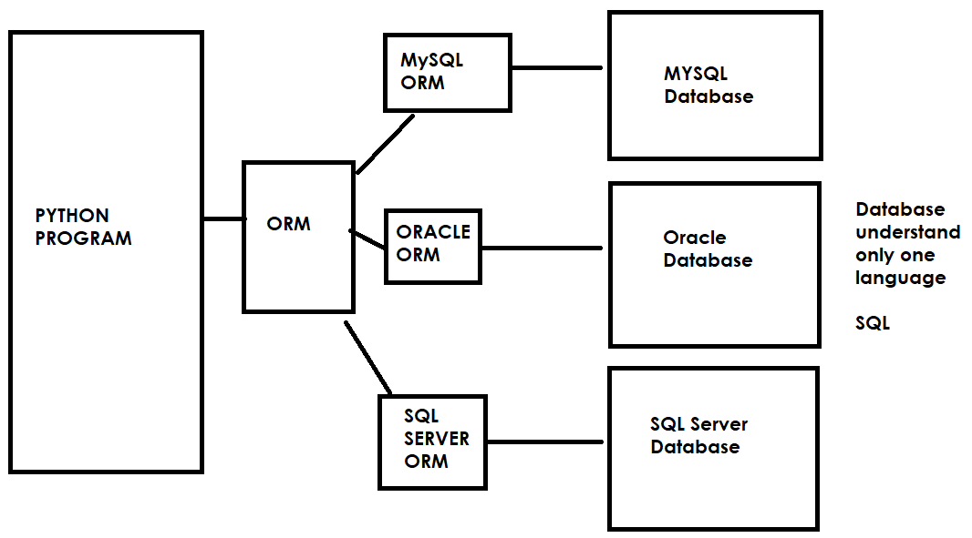

Django provides an inbuilt ORM called django ORM. This comes with various ORM engines/libraries.

Advantage of ORM
- Database Independence: ORM allows to develop database independent applications by avoiding using raw SQL statements
- SQL Injection: ORM avoids SQL injection problem, which allows to develop secured applications
- Object oriented: ORM allows communicating with database using classes and objects. Allows implements all object oriented concepts (class, objects, encapsulation, polymorphism, inheritance)

Django ORM provides the following ORM engines

Library name/engine/tool | Database
django.db.backends.sqlite3 | SQLite3
django.db.backends.mysql | MySQL
django.db.backends.oracle | Oracle
django.db.backends.postgresql | PostgreSQL

ORM is nothing but communicate with database using object oriented programming (classes and objects).

Basic steps to work with ORM
- Configuration orm engine/database

Configuration of database or orm is done inside settings.py

Configuration of SQL lite3 database

DATABASES = {
'default': {
'ENGINE': 'django.db.backends.sqlite3',
'NAME': BASE_DIR / 'db.sqlite3',
}

Configuration of MySQL database
DATABASES = {
'default': {
'ENGINE': 'django.db.backends.mysql',
'NAME': 'database-name',
'USER':'database-username',
'PASSWORD':'database-password',
'HOST':'ipaddress of system/hostname',
'PORT':'port no of mysql database'
}
}

Configuration of Oracle database

DATABASES = {
'default': {
'ENGINE': 'django.db.backends.oracle',
'NAME': 'database-name',
'USER':'database-username',
'PASSWORD':'database-password',
'HOST':'ipaddress of system/hostname',
'PORT':'port no of mysql database'
}
}

- Define models

What is model?
Model is class which represents table within database.
These models are defined inside a module called models.py(database)

How to create model?
Every model class is inherited from Model class provided by django.
Model class is available in django.db.models

Syntax:
From django.db.models import Model
class model-class-name(Model):
field-name=type
field-name=type
field-name=type

PS D:\Backup\Django9amMar\project9> django-admin startproject project9
PS D:\Backup\Django9amMar> cd project9
PS D:\Backup\Django9amMar\project9> python manage.py startapp app1
PS D:\Backup\Django9amMar\project9>

